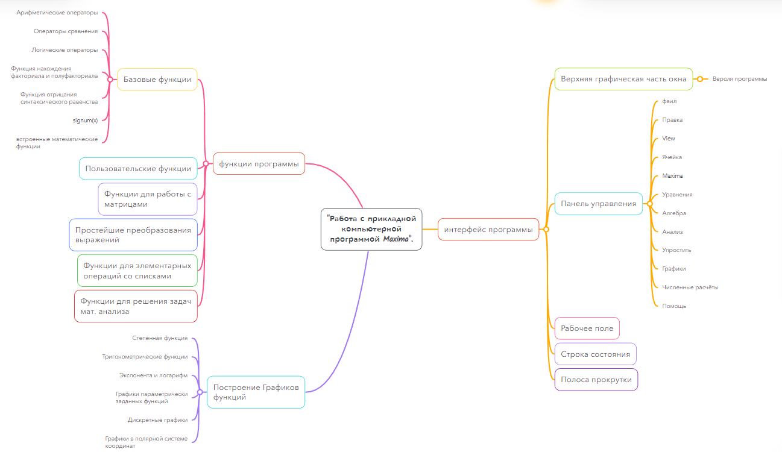
https://mm.tt/map/2511874355?t=NOVvAMxdIB

